Three Models of Light

Light shows up in many different strands of science. For example, consider grade-9 science. Understanding light is essential for astronomy because it makes up over 99% of our observations. Light also makes a strong appearance in electricity (efficient lighting, solar cells and light detectors), chemistry (atomic spectra) and ecosystems (photosynthesis). Students may find light confusing because it is modelled in three very different ways; rays, waves and photons. What is the evidence for each model and how do they fit together?

Ray Model (grade 10 science)

- Light Beams
a) A laser pointer is shone on a wall and you can see a dot of light. Why can you see the spot but you can’t see anything between the pointer and the spot? Sketch your ideas on the white board.
This is an example of something that the students have seen many times, but have probably never questioned. If they have trouble coming up with an idea, ask them to consider their eyes, and what is needed to see something.

The diagram should show the reflected light entering the eye. It should also show other reflected rays that do not enter the eye. This is important so that they don’t develop a standard misconception that the eye sucks the light towards it. When we simplify diagrams we should make the simplifications explicit.

Key Point: You can only see light, if it goes into your eye.

Pedagogical Note: The whiteboard is used so that students can explore tentative ideas in a small group. It lets you assess their understanding as they work through the questions. After each discussion, students should make diagrams and notes in the space provided. Make sure that you give them time for this. Writing, especially writing by hand, helps make the knowledge stick in their minds better.

Safety Note: the red laser pointers are very safe, but the green and blue are not. Treat all laser pointers as if they are dangerous and never let the beam go near someone’s eyes and only let students use the red ones and only if they agree to treat them responsibly.

b) How can the beam be made visible? Draw this on the white board.
This will be easier to answer. We need particles that will scatter light from different points in the beam into your eye. You can wave your fingers in the beam or spray water. Note: The light scatters forward. This means it will be see best by students just off the beam. Slowly move the beam from one side of the classroom to the other so that all can see it. Keep it pointed over their heads.

The diagram should show some rays that do not go into the eye.

Key Point: Light travels in straight lines or rays.

- Pinhole Cameras:
- Label the parts of the pin-hole camera, shown in cross-section below.

The device is made of two toilet paper cardboard tubes, a layer of wax paper in the middle and tinfoil with a small pinhole at one end.
- Look through the open end at some light sources. Describe what you see.
Provide a variety of bright light sources. The best ones are very bright. They should include some asymmetry so you can see that the image is reversed. Good options are LED flashlights half covered with coloured plastic, compact fluorescent bulbs and incandescent bulbs with visible filaments or black markings on the glass. Candles show a very definite up direction, but are not as bright. Show these after the more obvious ones. You can also make a large version of a pinhole camera with a box that fits over your head. This works best outside on a sunny day and students will be able to see the sun in a sky where the houses and trees are upside down.
- Add light rays to the diagram above to explain how an image forms.
The diagram should show why the image gets flipped. The diagram should also show some rays that do not go into the eye.
- What happens if the pinhole is made bigger? Add a second set of rays to explain.
More light will enter, so the image will be brighter, but overlapping images form a blurry one.
A second hole in the tin foil shows the explanation well.

Key Point: Rays can be used to predict what images we will see.
Curriculum Note: At this point, students have seen rays of light from a laser pointer. They have seen how the image formed by a pinhole camera is inverted and real and usually smaller. They are now ready to investigate the images formed by plane mirrors, curved mirrors and lenses.

Wave Model (grade 12)
- Diffraction:
- You have two pencils held together with elastics with a slight gap in between. You look through the vertical gap at a laser spot. What will it look like as the gap is squeezed?
- unchanged B) thinner C) wider D) it depends

Possibly B: Most students will predict that it gets thinner. This is the way shadows work and this is what it will do until it gets really small.
Possibly C: They probably won’t predict this. However, a few may have noticed this effect when they almost close their eyes and look at a small bright light source like an LED indicator in a dark room or a street lamp.
Possibly A: This is the case for a slit that is wider than the beam.
D: The correct answer is that it depends on the width of the slit.

A thin slit provides our first evidence that the ray model doesn’t work in all situations. This behaviour is called diffraction. Point the beam through the opening, so that everyone is looking at the same thing. Note: A really thin slit will show interference fringes, but leave this until after two-slit interference has been dealt with.

Pedagogical Note: Concept questions can help focus discussion and can stimulate discussion. If the students were given the question, ‘Why don’t we usually notice diffraction?’ they may feel overwhelmed and come up with nothing or they may come up with lots of irrelevant answers. Give students time to read and consider the question on their own before they start discussing.

- Watch Waves https://www.youtube.com/watch?v=IZgYswtwlT8 (½ minute) and
- Apertures and Diffraction https://www.youtube.com/watch?v=BH0NfVUTWG4 (2½ m). We usually don’t notice diffraction because light
- has very small wavelengths B) has very big wavelengths
- travels very fast D) travels very slowly
The first video shows diffraction in a natural setting. The second shows it in a lab where variables can be controlled. The amount of diffraction depends on the relative sizes of the slit and wavelength. This suggests that the wavelength of light must be really small.
- How does the ray model fit with the wave model of light?
http://phet.colorado.edu/en/simulation/legacy/wave-interference This simulation shows diffraction with water, sound and light. We can’t directly see the wave nature of light as we can with water. The ray model shows the direction of the velocity of the waves.

Pedagogical Note: we have not explained why diffraction occurs. We have just shown that it is a standard phenomenon with waves.

Key Point: Light bends when going through really narrow openings, like a wave does.
- Interference:
- Light is shone through two narrow slits, close together. What will you see on a distant screen?
- nothing B) one dot C) two dots D) many dots
Not A: Some light will get through.
Not C: They just learnt about diffraction. The two dots should be wider and they should overlap.
Not B: This is a reasonable prediction after learning about diffraction, but it misses interference.
It’s D: A few students may remember that waves interfere (grade 11). The overlapping diffracted spots should interfere to produce many bright spots, including one in the middle.

Pedagogical Note: Diffraction should be covered before interference because diffraction can be demonstrated with everyday materials and because it is needed to understand how two slits interfere.
- Use the transparencies and PhET simulation to explain what happened.
The whole image diagrams are easier to use for a quick first impression. Overlapping concentric circles will form a pattern because our brain focuses on the points of intersection.

The long thin strips were developed by Philip Freeman – a great teacher from Vancouver. They allow students to examine in detail where constructive interference will occur. The two sources interfere constructively when the difference in the path lengths is a whole number of wavelengths. The three transparencies formed by the pdf will make 5 pairs of red light, 5 of green and 5 of blue. They can also be used to explore beats, thin film interference and interferometers.

The PhET simulation does a better job of showing what happens in time. Expose students to as many different representations of phenomena as possible to build a deep understanding.
- What will happen if green light is used? The dots will be
- closer together B) farther apart C) brighter D) dimmer
Not C or D: The light may be brighter or dimmer depending on the power of the light source. Note: It will probably appear to be brighter, because the light sources will be of similar power, but our eyes are more sensitive to green light.

It’s either A or B: To answer this they have to remember what they may have learnt in grade 9 and 10 science about wavelength, colour and the electromagnetic spectrum. This is not a fair question. If wavelength was mentioned at all, it was just given as a fact to memorize and apply. Instead, this demo should be used to provide evidence that green light has a shorter wavelength than red light.

Key Point: Light interferes like a wave does. Different colours have different wavelengths.

Curriculum Note: At this point students have seen two phenomena that establish that light behaves like a wave. This wave-model is not as obvious as the ray model because the wavelength of light is so tiny and not directly observable. They are now ready to add several other phenomena where light shows wave-behaviour; refraction, polarization, multiple-slit interference (diffraction gratings) and single-slit interference. They are also ready to connect light with electromagnetism in the field unit and with relativity and quantum physics in the modern physics unit.

Quantum Model (grade 12)
- Wave-Particle Duality:
- Watch Double-slit interference buildup https://www.youtube.com/watch?v=H11hJWIcUY0&feature=youtu.be (1:00 – 1:44)
This shows that light is a
A) wave B) particle C) both D) neither
Not A: Waves do not appear as dots in a specific location.
Not B: Particles do not interfere, they do not cancel each other out.
Not C: See discussion about answers A and B.
It’s D! Light is something that sometimes behaves a like wave; in those cases we refer to it as an EM wave. Sometimes it behaves like a particle, and we refer to it as a photon. However, it is not a standard or classical particle not a wave. It is a new type of object - a quantum object.
- Watch Single electron double slit wave experiment http://www.youtube.com/watch?v=ZJ-0PBRuthc
This shows that electrons are
- waves B) particles C) photons D) quantum objects
Not A: Waves do not appear as dots in a specific location
Not B: Particles do not interfere like waves do. They do not cancel each other out.
Not C: That is the name for light.
It’s D! It is another quantum object that demonstrates wave-particle duality. However, unlike a photon, it has mass and charge and cannot travel at the speed of light.
- Watch Single Molecules in a Quantum Movie http://www.youtube.com/watch?v=vCiOMQIRU7I&feature=player_embedded using phthalocyanine - C₃₂ H₁₈ N₈.

Key Point: The wave model of light that is so well establishe needs to be modified to allow for particle-like behaviour. The particle model of electrons, protons and even molecules needs to be modified to allow for wave-like behaviour.

- Pair Creation and Annihilation: The rules of quantum physics don’t seem to make sense. However, the mathematics works really well and it has brought us computers, lasers, solar cells and Positron Emission Tomography (PET). PET is a medical scan that allows us to see biochemical activity in living organisms. The patient ingests a radioactive tracer attached to glucose which moves to wherever glucose is being used. The tracer emits a positron (the anti-matter equivalent of an electron) which annihilates when it meets an electron. The mass of the particles is turned into the energy of two photons. These move off in opposite directions to conserve momentum. The dark circles show where one pair of photons arrived at the detector. The grey circles show where a second pair arrived a bit later.
.
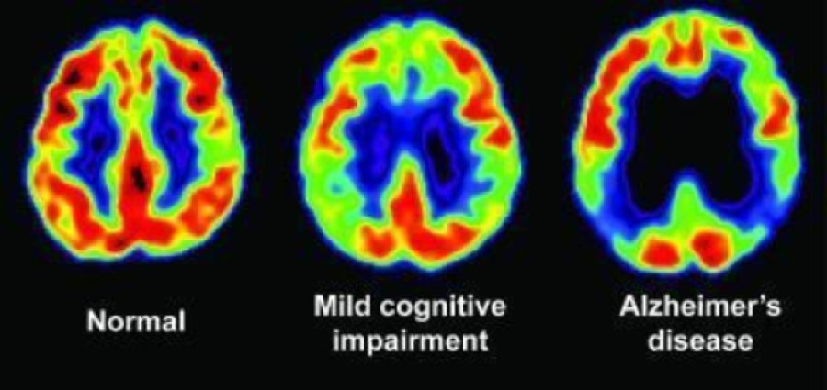 https://www.sciencedaily.com/releases/2009/07/090714085812.htm

The photons move off in equal and opposite directions. When two photons hit the detector at the same time, then we know that they came from a point somewhere along the line joining them. (Note: They travel different distances, so they actually hit at very similar but not quite the same times.) Two pairs of photons can locate a point in this 2-D cross-section but more points will be needed to form a 3-D image.

Key Point: Quantum physics may be weird but it is exremely useful.

